How to make a DXF

A DXF file (Drawing Exchange Format file) is a vector file that’s used to share drawing data between different applications. A DXF file is needed for the following 2D manufacturing methods:
- Laser cutting
- Water jetting
For more information on 2D manufacturing, see How-To: Design for different manufacturing methods.

How to make a DXF file in Fusion
Let’s say I have this part that I would like to get manufactured from SendCutSend:
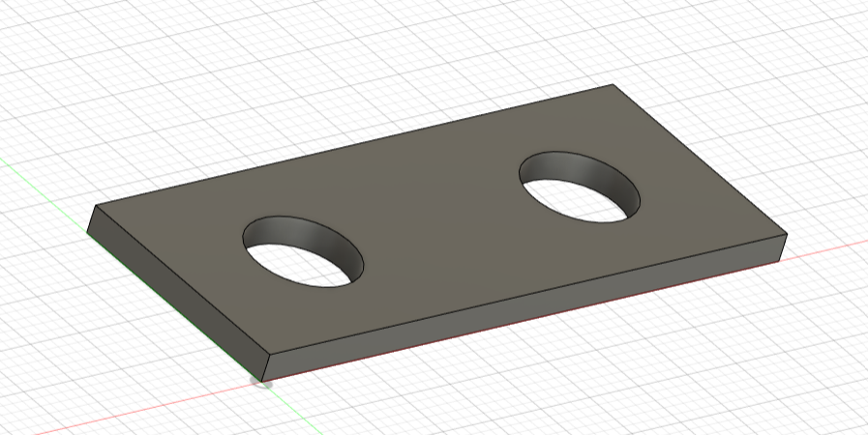

- Make a projected sketch
  - Click on the face that the laser (or water jet) will be cutting into (i.e. the face with the important geometry).
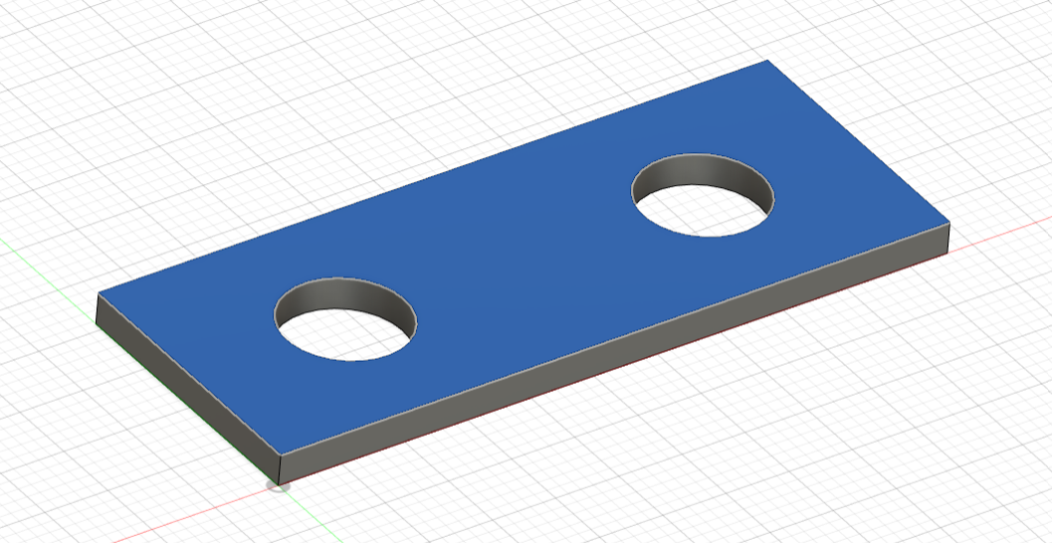
  - Hit ‘Create Sketch’.
  - Hit ‘P’ on your keyboard to activate the ‘Project’ feature.
  - Click on the same face you selected before and hit ‘OK’.
    - You should see a sketch of the face in purple.
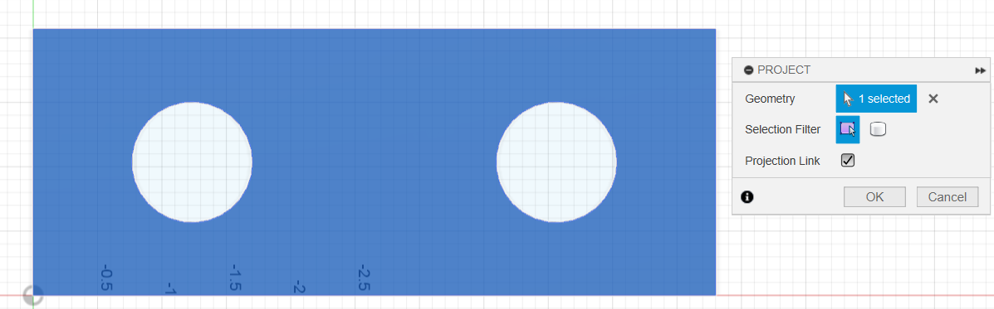
  - Select ‘Finish Sketch’.

IMPORTANT NOTE: Everywhere you see a purple line is where the laser (or water jet) will cut. If your sketch contains a line that goes through the part (like the picture below) then your part will be cut into 2 pieces! Always double check your sketch to make sure that it only contains lines that you want cut, and that it is not missing any important features.
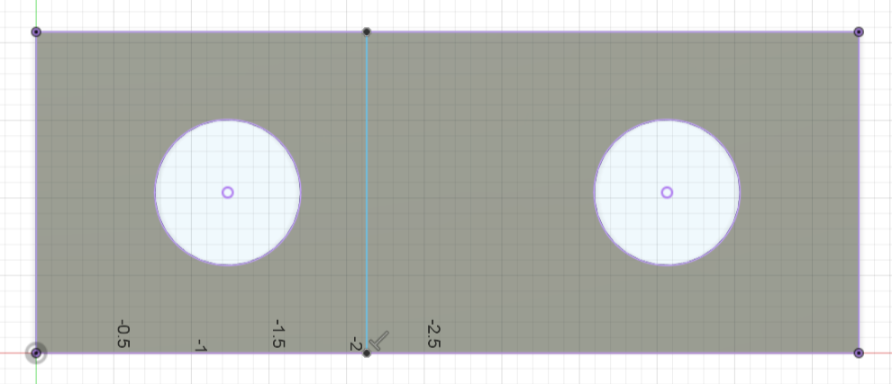

- Save the sketch as a DXF
  - Right click your sketch in the browser on the left.
  - Rename your sketch to ‘DXF’ so that others know what the sketch is for.
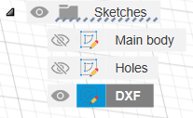
  - Right click on ‘DXF’ and select ‘Save as DXF’.
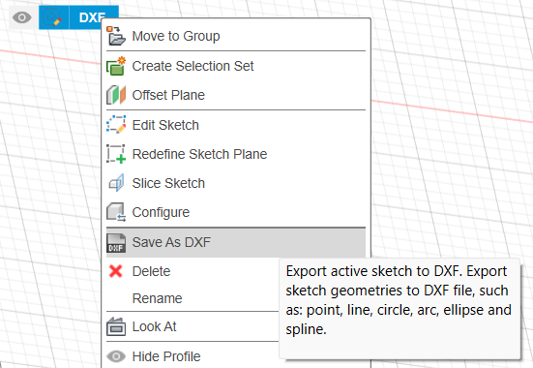
  - Save the sketch wherever you’d like with a name that makes sense.

- You’re done!

